Timeout error of xml

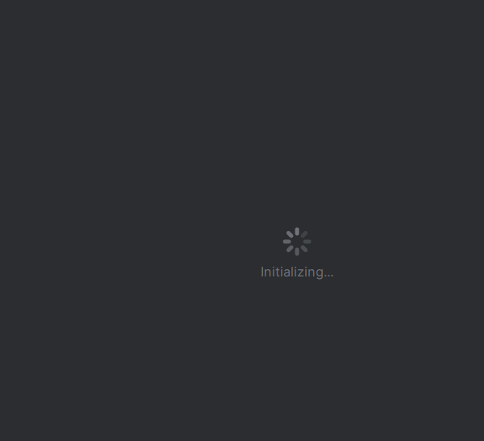

In case you are reading, or doing voice etc, then make sure you have permissions asked and android.manifest for permissions.

Secondly, make sure you use latest apk on emulator and phone if there’s two way communication